**Ideation Phase**

**Brainstorm & Idea Prioritization Template**

|  |  |
| --- | --- |
| Date | 25 June 2025 |
| Team ID | LTVIP2025TMID36909 |
| Project Name | Traffic Telligence Advanced Traffic Volume Estimation With Machine Learning |
| Maximum Marks | 4 Marks |

**Brainstorm & Idea Prioritization Template:**

Brainstorming provides a free and open environment that encourages everyone within a team to participate in the creative thinking process that leads to problem solving. Prioritizing volume over value, out-of-the-box ideas are welcome and built upon, and all participants are encouraged to collaborate, helping each other develop a rich amount of creative solutions.

Use this template in your own brainstorming sessions so your team can unleash their imagination and start shaping concepts even if you're not sitting in the same room.

Reference: <https://www.mural.co/templates/brainstorm-and-idea-prioritization>

**Step-1: Team Gathering, Collaboration and Select the Problem Statement**

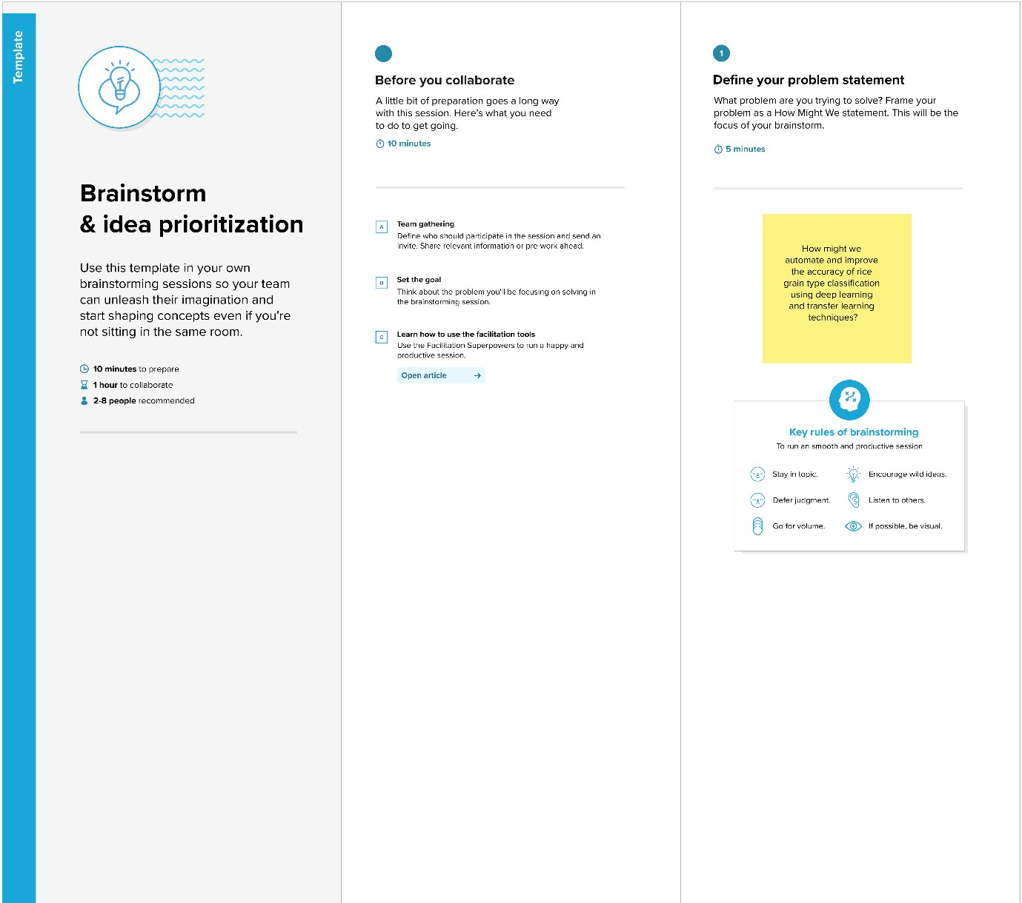

**Step-2: Brainstorm, Idea Listing and Grouping**



Oversee

project

Timeline,

team

coordination,

and reporting

Study traffic

systems,

gather existing

solutions,

define

problem scope

Deploy

sensors/camer

as, collect live

traffic data

(

vehicle count,

speed, etc.)

Filter, clean,

and prepare

the collected

data for

analysis

Analyze patterns,

train ML models

(

e.g., congestion

prediction,

accident

hotspots)

Build

dashboard/app

(

frontend +

backend),

integrate real

-

time monitoring

tools

Test all modules

(

data accuracy,

app functions),

find and fix issues

Create graphs,

charts, final

report, and

presentation

materials

The project's

goals (e.g.,

reduce

congestion,

improve traffic

flow, monitor

violations)

The

technologies/tool

s involved (e.g.,

sensors, cameras,

Python, ML, GIS)

Analyze patterns,

train ML models

(

e.g., congestion

prediction,

accident

hotspots)

Study traffic

systems, gather

existing

solutions,

define problem

scope

J

it

endra

Chaithanya

Kavya

S

ilpa

Rahel

**Step-3: Idea Prioritization**

